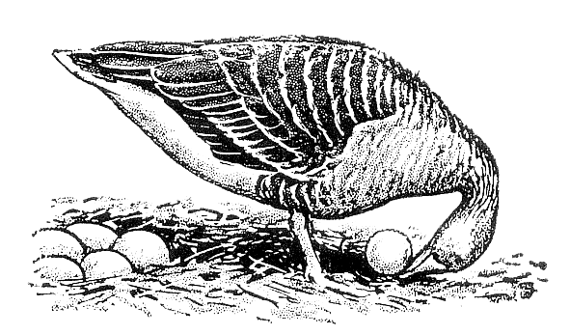

**Ethologische Gesellschaft e.V.**

Ethology Grant Application

Please complete the following application in the space provided. The application, including references and any supplementary materials, should not exceed the space provided. Font should be no less than 12pt. Please direct any questions regarding your application to Dr Alexander Kotrschal (email: alexander.kotrschal@wur.nl).

**Application due:** 31 August **Date:**

**Name:**

**Title of the proposed project:**

**Institution:**

**Address:**

**E-mail:**

**Summary of proposal (max. 200 words)**

**3 keywords:**

**Declaration:**

I confirm that I have been an active member of the *Ethologische Gesellschaft* for at least one year.

I will play an active role in data collection for this project.

I commit to presenting the study findings in *EthoNews*, at the *ECBB*, or at one of the society’s annual meetings within the next two to three years.

I understand that the granted funds must be used within one year from the date of approval. Upon completion of the project, I will submit a research report along with all relevant receipts to the treasurer.

If I publish the results, I will acknowledge funding from *Ethology* (Wiley) and the *Ethologische Gesellschaft* and provide a copy of the publication to the society’s manager.

If I publish the results I will consider *Ethology* as a potential journal for publication.

**Please send this application as ONE PDF document to the grants and awards officer of the Ethologische Gesellschaft (Dr Alexander Kotrschal: alexander.kotrschal@wur.nl).**

**1. Rationale and significance of this request and how it relates to theory and/or ethology in general (max. 1 page)**

**2. Hypotheses and predictions (max. 1/2 page)**

**3. Methods, data and statistics - please be specific (max. 1/2 page)**

**4. Timeline of the project**

**5. Budget – Please provide detailed information for all expenditures not to exceed €5,000. Do you have additional funds for this project? If so, please list funding sources and amounts.**

**6. References**

**7. CV (applicant)**