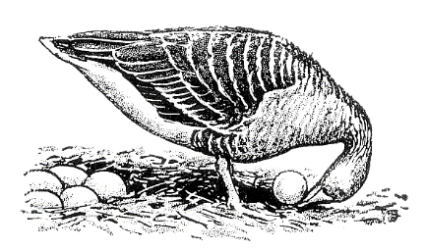

**Ethologische Gesellschaft e.V.**

**SEPA Direct Debit Mandate** (SEPA Core Direct Debit Scheme)1

Will be filled in by treasurer

Creditor Identifier (CI): ........................................................................................................................

Mandate reference: ............................................................................................................................

**Account holder:**

Last name: ............................................................ First name: .............................................................

Street name: ……………………………………………………… House number: …………………………………………………..

Postal code: …………………………………………….………… City: ……………………..…………..…………………..……………

Financial institute: ………………………………………………………………………………………….………………………………..

BIC: ………………………………………………………………….. IBAN: ……………………………………………………………………

I / we authorize the Ethologische Gesellschaft e.V. to collect payments from my account by direct debit. At the same time, I instruct my credit institute that the Ethological Society or Dr Rimbach as treasurer to redeem direct debits drawn from my account.

**Name and address of creditor:**

Treasurer of the Ethologischen Gesellschaft e.V.

Dr Rebecca Rimbach

University of Münster, Department of Behavioural Biology

Badestraße 13, 48149 Münster, Germany

Date: ..................................................................... Place: .....................................................................

Signature: …………..………………………………………………………………………………………………………….………………..

**Please send the completed form as a PDF to the treasurer of the Ethologische Gesellschaft e.V.:**

Dr Rebecca Rimbach, University of Münster, Institute for Neuro- and Behavioural Biology, Department of Behavioural Biology, Badestraße 13, 48149 Münster, Germany; e-mail: rrimbach@uni-muenster.de

1Data protection is of course guaranteed!